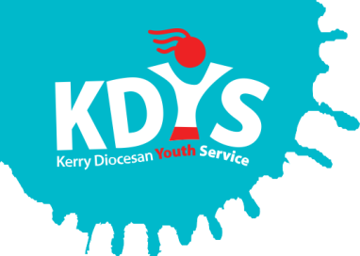

Project Worker

for the Killarney & Tralee Community Based Drug & Alcohol Initiatives

*Note: This is a joint recruitment process between two employers for two separate posts*

Job Description

|  |  |
| --- | --- |
| **Title of Post:** | Post A: Community Based Drugs & Alcohol Worker for Killarney (employed by KDYS at 17.5 hours per week)  Post B: Community Based Drug & Alcohol Worker for Tralee (employed by NEWKD at 17.5 hours per week). |
| **Location:** | Killarney and Tralee |
| **Reports to:** | Applicable line manager for each organisation |
| **Essential**  **Qualifications / Experience:** | * 3rd Level Degree (Min. level 8 or equivalent) in Youth & Community Work, Social Care, Drug and Alcohol addiction or related field. * At least 2 years work experience of working with people in addiction. * An excellent understanding of the nature of addiction and the different modalities of treatment. * Some experience in working with young people in a community/outreach setting. |
| **Desirable:** | * Familiarity with and the ability to work within the 4 tier model of addiction treatment services. * Experience in delivering specific evidence-based interventions with drug users in a community setting. * Experience in family support in the area of addiction and substance use. * Familiarity with the NDRIC framework and Protocols |

**Job Summary**

To deliver the Community Based Drugs & Alcohol Initiative for Killarney and Tralee areas.

**General Duties**

* To support people, referred into the project because of drug or alcohol misuse, and who are living in the Killarney and Tralee areas.
* To provide a Tier 2 service, offering initial and comprehensive assessment, evidence based interventions, information and support to people experiencing difficulty with drug/alcohol use in the community, through one to one intervention/ family support/ ‘sign posting’, ‘linking services’ and providing a safe environment in the community for people to engage with services and supports.
* To develop care plans & interagency care plans following the completion of the initial & comprehensive assessment.
* To refer individuals to other community based services, appropriate to their needs, in the projects area, e.g. housing supports, employment supports, addiction counsellor, KDYS Youth Services, education & training.
* To work with the Killarney & Tralee Community Based Drugs Initiative Advisory Committees who will broadly represent the communities served.

**Client Group:**

* Primarily young people but all those presenting will receive an initial assessment.
* Service users experiencing difficulties with substance use.
* Families and concerned persons of substance users.

**Specific Duties and Targets**

**The project worker will:**

* Support individuals and their families/concerned persons who are misusing substances. A maximum of 15- 20 clients will be engaged in the project as any one time.
* Administer initial assessments to all individuals referred for substance use as outlined in the Cork/Kerry Case Management Manual. The worker will adhere to the protocols as set out in the manual.
* Ensure all individuals referred are recorded on the National Drug Treatment Reporting System (NDTRS)
* Use evidence based interventions.
* Support clients to attend pre-admission meetings to residential treatment.
* Maintain continuous contact with the client groups who are participating in outpatient and residential treatment programmes.
* Support families either on a one-to-one or group basis, who live or are affected by another person’s addiction.
* Undertake relevant substance related training as identified by SRDTF/KDYS
* Participate in meetings and training as required.
* Participate in Service User Involvement Framework with identified training and action plans on levels of involvement for 2018.
* To work to all policies and procedures as relevant to both organisations.
* Budget and Resource Management.
* Maintain all records and files as required to a high standard

**Responsibilities of all Employees**

* Work in accordance with KDYS & NEWKD Policies and Procedures as applicable.
* Implement Health and Safety procedures.
* Implement appropriate Quality Assurance systems.

Person Specification

**Essential Criteria**

* An excellent understanding of the nature of addiction and the different modalities of treatment.
* Training and experience of working with people in addiction and have at least 2 years work experience in this field.
* Experience in working with young people in a dynamic/engaging way using a variety of methodologies.
* Experience of using strong interpersonal skills (written and oral) across a diverse and wide audience
* Experience of having worked with multiple time demands and deadlines, exercising judgement on time management & level of attention to detail
* The ability to network and liaise for the benefit of the clients with other key agencies.
* The ability to work on his/her own initiative.
* Be motivated, approachable, dependable and have good communication skills.
* Be in good health.

**Terms & Conditions of Employment**

|  |  |
| --- | --- |
| **Tenure** | Specified Purpose contract linked to Maternity Leave cover  (approx. 6 months) |
| **Working Hours** | 17.5 hours per week with each organisation, totalling 35 hours pw |
| **Remuneration** | Salary scales apply |
| **Other** | Own car required and full clean driving licence |

**This project is funded by the HSE**

**and supported by the Southern Regional Drugs and Alcohol Task Force**

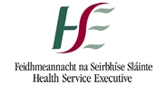[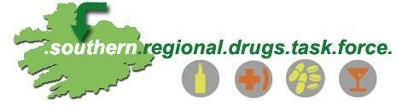](http://www.google.ie/url?sa=i&rct=j&q=&esrc=s&source=images&cd=&cad=rja&uact=8&ved=0ahUKEwj5rIfM9orUAhWlI8AKHW-uBfwQjRwIBw&url=http://www.cdys.ie/macroom-community-based-drugs-initiative.html&psig=AFQjCNFAPgssuzDbRlbXM4qscbSr-B0TCQ&ust=1495797640573837)