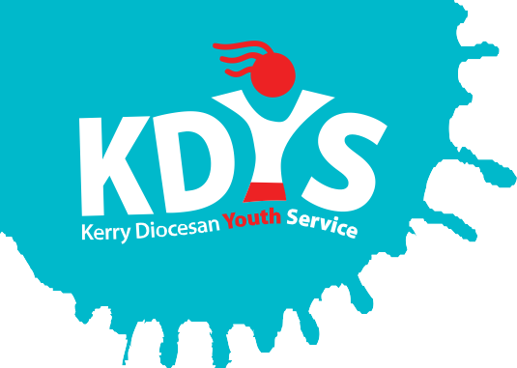
KDYS are recruiting!!!!

KDYS is a voluntary youth work organisation providing a range of quality services responding to the needs of children, young people, their families and communities in the Diocese of Kerry.

Applications are invited for the following:
Post A:
Lead SPY Project Worker
(35 hours per week, 1 year fixed term contract)
The successful candidate will work with young people and the community in Listowel and North Kerry to develop and delivery youth work programmes and supports to young people in the area as per the funding criteria.
Applicants require:
- A relevant degree in youth work, community work, family support, social care, social work, education or other relevant discipline
- Minimum 3 years relevant work experience
- Experience in the design and delivery of a wide range of programmes for vulnerable young people across the five national outcomes as per the national youth strategy

Post B:
Volunteer Support Worker
(12 hours per week, 1 year fixed term contract)
The successful candidate will provide support to youth clubs and volunteer led projects in their designated regions, ensuring that all required standards all met, as part of the KDYS Club Support Team.
Applicants require:
- A relevant qualification in youth work, community work, or other relevant discipline, is an advantage.
- Minimum 3 years relevant experience in the youth work and/or community sector.

Both posts require:
- Fluency in English, both written and verbal Full, clean drivers license

A panel may be formed from which future vacancies may be filled.

Job Descriptions and Application Forms available to download from www.kdys.ie, or by request to: humanresources@kdys.ie

Please submit completed Application Form by email on or before:
12 noon, Friday 22nd September 2017

KDYS is an Equal Opportunities Employer
KDYS is a Health Promoting Youth Organisation
KDYS complies with the Governance Code for Community, Voluntary and Charity Organisations in Ireland

