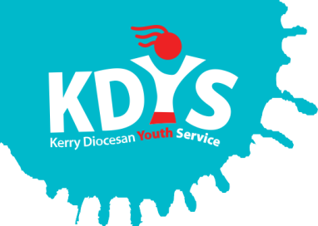

# ***Applications are invited for the following***

**Youth Worker**

***(Youth Participation Worker)***

**(8 month Fixed term contract, 35 hours per week)**

KDYS, the leading youth organisation in South West Ireland as affirmed by the Council of Europe awarding the Quality Label for Youth Centres to our Killarney headquarters. We provide a range of quality services responding to the needs of children, young people, their families and communities.

The successful candidate will make a difference in the lives of young people aged 18 – 24, by promoting a culture of integrity, youth participation and development, in line with our organisational values.

Applicants should have relevant degree in youth work, education or other relevant discipline and a minimum 1 year relevant experience of working with young people in a paid capacity or 2 years in a voluntary capacity.

**PLEASE VIEW THE JOB DESCRIPTION FOR FULL DETAILS OF THE POST AND THE REQUIREMENTS.**

***A panel may be formed from which future vacancies may be filled***.

Job Description and Application Form, available to download from [www.kdys.ie](http://www.kdys.ie), or by request to: [humanresources@kdys.ie](mailto:humanresources@kdys.ie)

Please submit completed Application Form **on or before:**

**2 pm, Monday 8th October 2018**

***Shortlisting will apply.***

***Interviews to take place week beginning 15th October***

*KDYS is an Equal Opportunities Employer*

*KDYS is a Health Promoting Youth Organisation*

*KDYS complies with the Governance Code for Community, Voluntary and Charity Organisations in Ireland*

