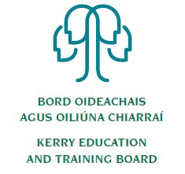
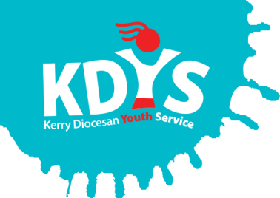

Kerry Diocesan Youth Service

invites applications for

Youthreach Resource Workers

KDYS/KETB Youthreach Programme offers a flexible and dynamic programme of integrated general education, vocational training and work experience.

KDYS in partnership with KETB invites applications for the following Youthreach Resource Worker posts (providing Maternity/Parental Leave Cover)

These are part time roles to provide Maternity/Parental leave cover, working as part of a staff team reporting to the Youthreach Co-ordinator. Duties assigned to these roles include the preparation, development and delivery of specified QQI / LCA curriculum modules.

Post A: Based in Tralee Youthreach Leaving Cert Applied, this is a part time role of 25 hours per week to provide Maternity Leave Cover, duties assigned to this role will include the delivery of LCA modules to young people in the areas of Health, Sport and/or IT

Post B: Based in Transforum Alley Youthreach, this is a part time role of 18 hours per week for 15 weeks to provide Parental Leave Cover, duties assigned to this role will include the delivery of QQI 2/3/4 in an Integrated Programme in the areas of One to One Literacy, Group Literacy and Personal & Interpersonal Development

- Applicants should have a recognised and relevant 3rd Level Degree (Level 8 or equivalent) in Education, Youth Work, or a related field
- Previous experience of working with vulnerable young people in an informal education setting is desirable
- Remuneration is in accordance with the Youthreach Resource worker salary scale approved by the Department of Education. Commencing salary will be at point 1 of the scale and will be pro rata for contracted hours
- Commencing September 2018
- A panel may be formed from which future vacancies may be filled.

Job Description and Application Form, available to download from www.kdys.ie, or by request to: humanresources@kdys.ie

Please submit completed Application Form on or before:
3 pm, Tuesday 10th July 2018

KDYS is an Equal Opportunities Employer
KDYS is a Health Promoting Youth Organisation
KDYS complies with the Governance Code for Community, Voluntary and Charity Organisations in Ireland

