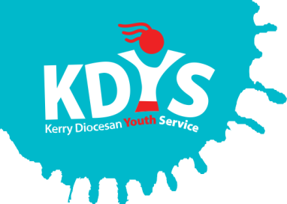

Applications are invited for the following

KDYS Development and Volunteer-Led Support Services Officer
(9 month Fixed term contract, 35 hours per week)

KDYS, the leading youth organisation in South West Ireland as affirmed by the Council of Europe awarding the Quality Label for Youth Centres to our Killarney headquarters. We provide a range of quality services responding to the needs of children, young people, their families and communities.

KDYS is committed to the provision and development of sustainable Volunteer-Led Youth Clubs and Projects. The future of KDYS Youth Clubs is dependent on the development of a new business model for a sustainable future. The new business model will be developed in conjunction with Volunteer Leaders, Young People, KDYS Board and Management, and other Stakeholders as relevant. It will seek to ensure that KDYS Youth Clubs are high quality provisions, with measurable outcomes, incorporating the voice of young people.

The post holder will lead out on the design, implementation and evaluation of a Business Plan for KDYS volunteer led services. This is a full time role operating at senior level within KDYS and requires a strategic focus. The initial contract is for nine months, with any renewal of the contract beyond the initial fixed term dependant on the successful development and delivery of a sustainable business model.

The KDYS Development and Volunteer-Led Services Officer will be a dynamic individual, who is highly motivated, flexible and values the contribution of key stakeholders to achieve success
Applicants should have relevant 3rd level degree and a minimum 2 years relevant work experience and a working knowledge and understanding of Irish charity fundraising sector with experience in non-profit fundraising, development and volunteering

PLEASE VIEW THE JOB DESCRIPTION FOR FULL DETAILS OF THE POST AND THE REQUIREMENTS.

A panel may be formed from which future vacancies may be filled.
Job Description and Application Form, available to download from www.kdys.ie, or by request to: humanresources@kdys.ie
Please submit completed Application Form on or before:
5 pm, 28th August 2019

Shortlisting will apply.

KDYS is an Equal Opportunities Employer
KDYS is a Health Promoting Youth Organisation
KDYS complies with the Governance Code for Community, Voluntary and Charity Organisations in Ireland

