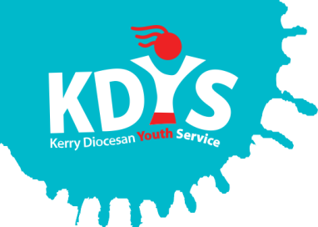

Applications are invited for the following

KDYS Youth Justice Worker

KDYS is the leading youth organisation in South West Ireland as affirmed by the Council of Europe awarding the Quality Label for Youth Centres to our Killarney headquarters. We provide a range of quality services responding to the needs of children, young people, their families and communities.

About KDYS Youth Justice Work
KDYS has a long history of developing innovative responses to the needs of young people that enhance their lives, their families and the wider community. In partnership with the Kerry Gardaí, the service response is based on clear evidence of need informed by Garda crime statistics. The net result is that young people who are most in need of a service will get that service. In 2019, the KDYS further developed the KEY Service to extend to a limited delivery to children aged 8-11 years old. Over the last 12 months the KEY Service have engaged in a co-design phase of an Action Research pilot to determine the most suitable response to engage with this younger age group.

Job Summary
Work with children, young people, their families, agencies and the community in the Kerry Division to develop and deliver suitable interventions and supports to young people in the area as per the funding criteria. The project is funded by the Department of Justice and Equality and the European Social Fund.

Applicants should have relevant professional qualification in youth work, community work, family support, social care childcare, education or other relevant discipline and demonstrable experience of devising, implementing and evaluating programmes/ interventions/responses for ‘at risk’ youth.

PLEASE VIEW THE JOB DESCRIPTION FOR FULL DETAILS OF THE POST AND THE REQUIREMENTS.

A panel may be formed from which future vacancies may be filled.
Job Description and Application Form, available to download from www.kdys.ie, or by request to: humanresources@kdys.ie
Please submit completed Application Form on or before:
5pm, Monday 23rd March 2020

Shortlisting will apply.

KDYS is an Equal Opportunities Employer
KDYS is a Health Promoting Youth Organisation
KDYS complies with the Governance Code for Community, Voluntary and Charity Organisations in Ireland
