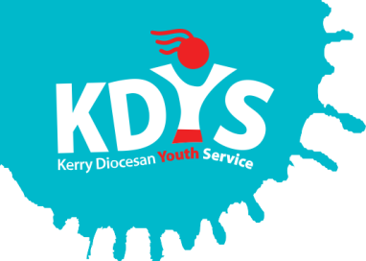

Applications are invited for the following

KDYS Action Researcher
(KEY Pilot Project – Preventative Work with 8-11 year olds and their families)

Would you like to work on a project contributing directly to the development of Ireland’s future youth justice policy?

This new post within KDYS is concerned with documenting innovative practice, capturing evidence of inputs, outputs and outcomes to demonstrate the value and impact of a crime prevention response to young people aged 8-11 years and their families. The learning from the action research will build the case to support the potential expansion of the work with this cohort within KDYS and across Ireland.

Working in a collaborative manner with KDYS staff involved in the KEY Service, Partner organisations and with academic oversight from UL, this post is a dynamic opportunity for someone to focus on action research and further develop their skills and capacities in this area.

Applicants should have relevant professional qualification in youth work, community work, family support, social care or other relevant discipline and demonstrable experience of working on and delivering research projects, preferably within a relevant sector.

PLEASE VIEW THE JOB DESCRIPTION FOR FULL DETAILS OF THE POST AND THE REQUIREMENTS.

A panel may be formed from which future vacancies may be filled.
Job Description and Application Form, available to download from www.kdys.ie, or by request to: humanresources@kdys.ie
Please submit completed Application Form on or before:
5pm, Monday 27th May 2019

Shortlisting will apply.
Interviews to take place week beginning 4th June
KDYS is an Equal Opportunities Employer
KDYS is a Health Promoting Youth Organisation
KDYS complies with the Governance Code for Community, Voluntary and Charity Organisations in Ireland

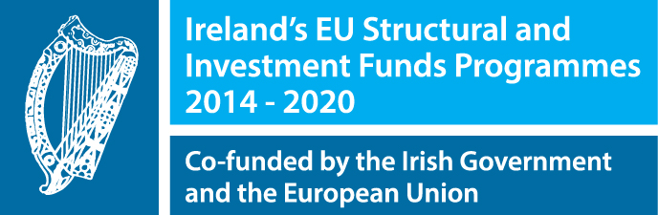 | 