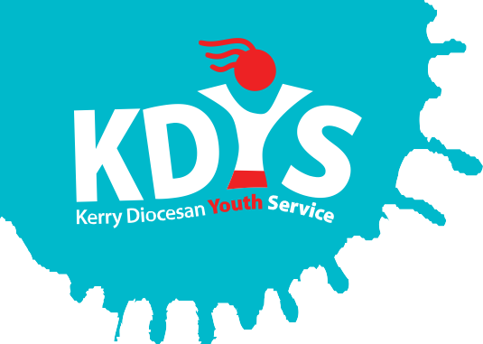
Kerry Diocesan Youth Service

invites applications for a

Project Administrator

KDYS operates our “Neighbourhood Youth Project” in Killorglin, Co. Kerry, in partnership with TUSLA. KNYP is a community based youth development and family support service working with young people and their families. KNYP looks to strengthen the connection of young people to their families and their communities.

This position is a front of house role providing a warm welcome to young people and their families while supporting project delivery through providing an efficient, confidential and flexible administration service.

Applicants should a relevant professional qualification and have at least 2 years’ experience in an administrative function.

This is a specified purpose contract
This contract is part time at 17.5 hours per week.
The salary will be commensurate will qualifications and experience.

A panel may be formed from which future vacancies may be filled.

Job Description and Application Form, available to download from www.kdys.ie, or by request from email: humanresources@kdys.ie

Please submit completed Application Form on or before:
12 Noon of Friday 21st April 2017
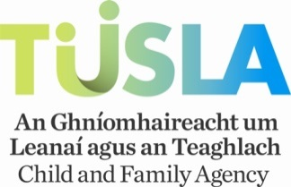
KDYS is an Equal Opportunities Employer
KDYS is a Health Promoting Youth Organisation
KDYS complies with the Governance Code for Community, Voluntary and Charity Organisations in Ireland

