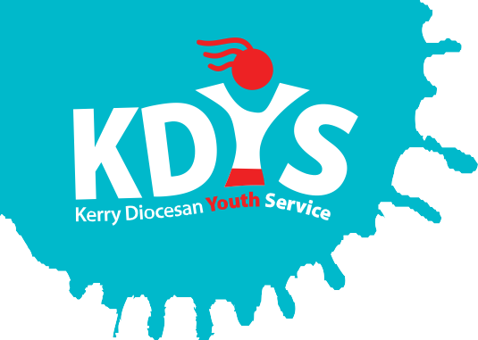
Kerry Diocesan Youth Service

are inviting applications for a

Governance & Compliance Officer

KDYS is the leading youth organisation in South West Ireland as affirmed by the Council of Europe awarding the Quality Label for Youth Centres to our Killarney headquarters. We are seeking an exceptional individual who will make a difference in the lives of young people and their families through supporting the Board, CEO and Senior Management Team to forge a culture of integrity and compliance with our organisational values:-

- Young people at the heart of everything we do
- Concern for the young person’s development; personal, social, educational and spiritual
- Commitment to partnership with young people, volunteers, communities and funders
- Upholding quality standards of integrity and professionalism.

This role is delivered by evaluating risk management, governance, planning and control activities across the organisation. The Governance & Compliance Officer is expected to add real value to every project we work on by evaluating and, where needed, challenging how things are done by putting forward suggestions as to how they can be done better. The post-holder will support KDYS to implement continuous improvement, providing an assurance that any risks which threaten the achievement of our strategy, objectives and activities are managed efficiently and effectively.

Applicants should be educated to a minimum of degree level and have at least 2 years’ experience at a senior level in a business administration function, corporate governance or similar.

The contract of employment will be for 12 months initially.
This contract is whole time at 35 hours per week.
The salary will be commensurate will qualifications and experience.

A panel may be formed from which future vacancies may be filled.

Job Description and Application Form, available to download from www.kdys.ie, or by request from email: humanresources@kdys.ie

Please submit completed Application Form on or before:
12 Noon of Friday 28th April 2017

KDYS is an Equal Opportunities Employer
KDYS is a Health Promoting Youth Organisation
KDYS complies with the Governance Code for Community, Voluntary and Charity Organisations in Ireland

