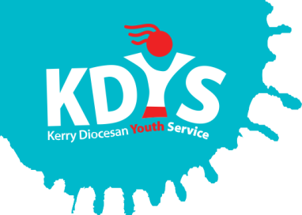

# ***Applications are invited for the following***

Project Worker

with the Killarney & Tralee Community Based Drug & Alcohol Initiatives

**Specified Purpose Contract linked to Maternity Leave Cover**

This is a joint recruitment process between two employers for two separate posts. The successful candidate will be employed by KDYS for the Killarney CBDI for 17.5 hours per week and employed by NEWKD for the Tralee CBDI for 17.5 hours per week

These projects are delivered in partnership with the HSE/SRD&ATF. The successful candidate will support people living in the Killarney & Tralee areas who have a problem with drug or alcohol misuse.

Applicants should have a 3rd Level Degree (Level 8 or equivalent) in Youth Work, Social Care, Drug/Alcohol Addiction studies or a related field and at least 2 years work experience of working with people in addiction.

***A panel may be formed from which future vacancies may be filled***.

Job Description and Application Form available to download from [www.kdys.ie](http://www.kdys.ie), or by request to: [humanresources@kdys.ie](mailto:humanresources@kdys.ie)

Please submit completed Application Form by email **on or before:**

**3 pm, Wednesday, 24th January 2018**

**This project is funded by the HSE**

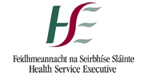[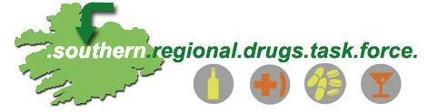](http://www.google.ie/url?sa=i&rct=j&q=&esrc=s&source=images&cd=&cad=rja&uact=8&ved=0ahUKEwj5rIfM9orUAhWlI8AKHW-uBfwQjRwIBw&url=http://www.cdys.ie/macroom-community-based-drugs-initiative.html&psig=AFQjCNFAPgssuzDbRlbXM4qscbSr-B0TCQ&ust=1495797640573837)**and supported by the Southern Regional Drugs and Alcohol Task Force**